Priests of the Sacred Heart
______________________________________________________________________________________________________________________

Provincialate Offices, United States Province General Phone: 414-425-6910
7373 S. Highway 100, P.O box 289 Fax: 414-425-2938
Hales Corners, Wisconsin 53130-0289

October 12, 2015
Dear Confreres,

I have been looking for an opportunity to write to you since I officially took office as Provincial Superior. These first weeks have been interesting. As you may be aware, I was in Washington D.C. for the mass with Pope Francis; I attended the funeral for Deacon David’s mom in Tampa, FL; and last week I was in Sioux Falls for the CPOSH Board meeting. Today I am in Chicago visiting our formation community. In between travels, I’ve had a number of meetings with individuals and communities, hospital visits with Byron Haaland and Joe Dean, who, thankfully are both recovering from serious health issues, and I’ve gotten settled in the office and in my community at Sacred Heart at Monastery Lake.
From September 30 –– October 2, the Council and I began our retreat at the Siena Center in Racine, WI. We met Wednesday afternoon and evening, and Thursday morning, but returned to Milwaukee on Thursday afternoon to be with Byron.
During the time that we did meet we set up our agenda for the year. Our priorities are as follows (not in any particular order):
- Community Life
- Spirituality
- Formation
- Senior Life
- Sacred Heart Seminary and School of Theology
These priorities will be fleshed out when the Council and I meet again.
Our Mission Statement states: “As American SCJs, Inspired by God’s love revealed in the Heart of Christ, seeking fidelity to his Gospel through the charism of Leo John Dehon, and nourished by the Eucharist, we are called to live together simply, to pray together, and to be, especially among the poor, ‘prophets of love and servants of reconciliation,’ offering ourselves with Christ to a world which hungers for justice and peace.”
Soon, I will begin the formal visitations of each local community. My first visitation will follow the Sacred Heart Southern Missions Board Meeting on November 3. I will be with the Mississippi Community from November 4-9.
I plan to begin and end each visitation with a community meeting. In between, I will meet with each member of the local community. During the first community meeting we will have an opportunity to pray, reflect and share together on the following questions:
- How are we living our communal life together?
- How am I doing in community?
- What am I (we) willing to do to improve our life together?
The second community gathering will conclude the visitation with prayer, reflection and encouragement to deepen our commitment to live together in community.
At our Chapter and recent assemblies there has been a call to improve and renew our common life. I hope that by doing the visitations a little differently each of us will have an opportunity to do just that.
Until we are able to be together, be assured of my thoughts and prayers. Please pray for me from time to time.

Fraternally,
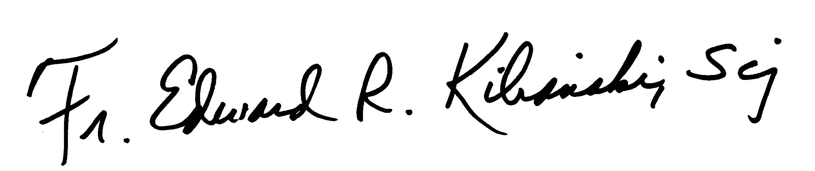

Ed Kilianski, SCJ
Provincial Superior

