Priests of the Sacred Heart
______________________________________________________________________________________________________________________

Provincialate Offices, United States Province General Phone: 414-425-6910
7373 S. Highway 100, P.O box 289 Fax: 414-425-2938
Hales Corners, Wisconsin 53130-0289

December 22, 2015
Dear Confreres,

As we begin this New Year I wish to extend to each of you wishes for a happy and healthy 2016. May the Lord bless you, as well as our United States Province, with peace, happiness and health.

You may recall that on December 14, 2015, I, Fr. Q. Nguyen, Fr. D. Nguyen, Br. Presto and Fr. Kurps visited with the Dehon Formation Community in three separate meetings: one with the formation team (Br. Duane Lemke and Fr. Tim Gray), one with professed SCJs who are not in formation, and one with the students. Due to holiday schedules, several members of the student community were unable to be present. Each of these meetings was well received.

At our provincial council meeting on December 15 and 16, 2016, the Council and I continued our discussion of our formation programs from the meeting in Chicago and the November Council meeting. I share with you now some of our reflections:

New academic and formative possibilities: For many years SCJs have expressed concern that the formation program is not near an SCJ ministry. Students do not have frequent interaction with SCJ communities outside of their own and only limited exposure to province ministries. It has often been suggested at assemblies and other gatherings that the province seek a parish or other ministry in the Archdiocese of Chicago so that there would be something closer to the formation community.

Given our personnel concerns, councilors talked about whether it might instead be beneficial to move the formation programs to areas where there already are established province ministries. For it to work, the local community would need to commit to regular interaction with the formation program. The possibilities discussed:

- Theology
- Houston –– If the theology program were to move to Houston, students could attend St. Mary’s Seminary. The institution has a significant number of seminarians from religious communities along with diocesan seminarians. There are also lay students studying for master’s degrees at St. Mary’s. Seminarians sponsored by religious communities generally live in a formation house off-campus. The SCJs would plan to do the same. The SCJ students would live with a formation director; SCJs in the Houston community would be able to assist the director, and students would have the possibility of doing ministry at Our Lady of Guadalupe.

- Sacred Heart Seminary and School of Theology –– There is also the option of moving the theology program to SHSST (students would live in a separate formation community).

- College–– If the undergraduate program were to be based in Mississippi students would be able to attend Christian Brothers University in Memphis. It offers the necessary number of credits for philosophy and theology. Students would live in a formation house with a director; as in Houston, SCJs in the Mississippi community would be able to assist the director and students would have the opportunity to serve in ministry in Sacred Heart Southern Missions.

- Novitiate –– It was suggested that the novitiate be in the Milwaukee area, but not within an established community. There are several SCJs in the area with extensive formation experience; they could assist the novice master. With a large number of SCJs living in Milwaukee, and many who pass through the area for meetings, the novices would have many opportunities to interact with the membership.

Dear brothers, I want to emphasize that these are just possibilities being discussed, no decisions have been made. I am asking for your reflective thoughts, comments, affirmations, concerns, criticisms and suggestions before the decisions are made. It is possible that the proposed plan could be put into effect as early as September, 2016. Perhaps, it will take longer.

The primary reasons for the discussion are three-fold:

- The long-time concern that those in formation be closer to an SCJ ministry and community.

- With the current program a student might spend ten or more years in the same house (with his only break being for his apostolic year).

- Those in formation need more exposure to the province, its communities and ministries.

I, as Provincial Superior, and the Provincial Council know it is important and valuable to collaborate and dialog with each of you. We respectfully ask for your input regarding the formation discussion by January 27, 2016, so that further discussion can take place at the February council meeting.

Fraternally in the Sacred Heart of Jesus,

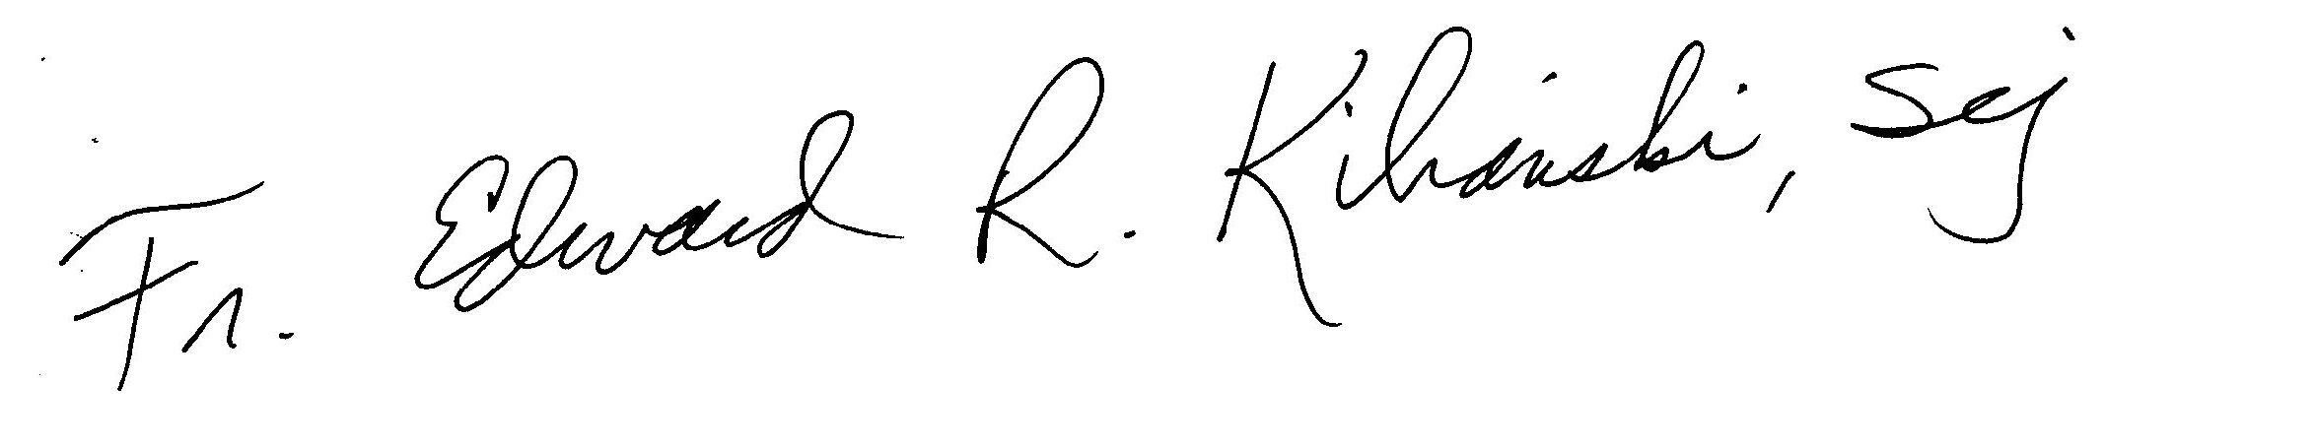

V. Rev. Edward R. Kilianski, SCJ
Provincial Superior
And the Provincial Council

