Priests of the Sacred Heart
______________________________________________________________________________________________________________________

Provincialate Offices, United States Province General Phone: 414-425-6910
7373 S. Highway 100, P.O box 289 Fax: 414-425-2938
Hales Corners, Wisconsin 53130-0289

February 8, 2016
Dear Brothers,
The season of Lent is upon us once more, a season which coincides with springtime and the rebirth of nature and new life. It is a time for us to grow spiritually and experience a reawakening of our relationship with God during the forty days of Lent, which culminate at Easter with the Lord’s passion, death and resurrection. In his message for Lent, Pope Francis reminds us of how we have already received God’s goodness and mercy when we were clothed with Christ on the day of our baptism. We have been reborn in Christ and the season of Lent is a time for exploring the wonder and beauty of our baptismal calling in Christ.
The purpose of Lent is not to make us feel disheartened or uncomfortable in the way we live our faith, but it is a call to self-examination and for taking a fresh look at our attitude and behavior towards others. Unknowingly we can little by little become self-centered and lapse into what Pope Francis calls “indifference to others”.
Our baptism into the Body of Christ and our religious profession as Priests of the Sacred Heart do not allow us to ignore the needs and sufferings of those around us. The traditional penitential nature of Lent is not intended to punish us, but to remind us of our need for God’s grace and of our obligation to put others before ourselves, especially in our communities. Awareness of the presence of God surrounding us and of the need to engage in practical acts of charity will ensure that we grow in God’s grace and become more Christ-like, more Dehonian, in this holy season now beginning.
Items of interest in the province:
Necrology:
With this letter a Necrology for the Priests of the Sacred Heart in North America is included. At the suggestion of one of our confreres during a visitation, I asked Mary Gorski to put this together for us. It fits perfectly into the breviary. It is important that we remember and pray for those who have gone before us. Mary is also working on updating an electronic version of WE REMEMBER, a book of our deceased SCJs.

Formation Letter:
I and the Council were extremely pleased and grateful for members’ response in regards to the formation program, in general, and possible changes for the future. Input came from all areas and age groups in the province; all responses were reviewed. In the weeks ahead the council will continue to investigate possibilities; a more significant response from the council on formation will come after its March 16th meeting. The council and I are seriously listening to your input; formation continues to be a priority of the province.
Vacation Policy:
During our Provincial Council Meeting last week, questions were raised about the Province Vacation Policy. In the spirit of our vow of poverty, the policy adopted by the Provincial Council on January 19, 1995, was reaffirmed.

That policy states:

- Each of our members has a need for adequate rest and recreation. To assure good order in the matter of vacations, the following applies:

- The length of vacation will be four weeks each year for all members. *
- The place of vacation, travel arrangements, expenses, and the like are to be worked out with one’s Coordinator [now Superior].
- Any travel outside of the continental U.S.A., with exception of short excursions into Mexico and Canada, for vacation or any other reason, requires the approval of the Provincial Superior.
- International home visits –– Several members of the province are either from other entities, or have family in countries outside of the United States. It is understood that international members need to have the opportunity to visit their home countries. ** More information is included in the minutes of the Council meeting.

*Exempts those who are retired. (Province Handbook, Retirement Guidelines, Page 1)
**Added February 2, 2016

Celebration of ordination jubilees:
Several SCJs have asked that the policy regarding the celebration of jubilees of ordination be
reviewed. Currently, religious jubilees are celebrated at the province level and jubilees of
ordination are celebrated locally with the community, friends and family of the jubilarians.
An anniversary of 50 or 60 years of priesthood is significant. The council agreed that a
province celebration of those noting 50 or 60 years of priesthood will be held; however, it is
to be separate from the celebration of religious jubilees. In 2016, the ordination jubilees will
be celebrated in fall; details will be worked out at a later date. Those celebrating their 50th
anniversary of priesthood will also be acknowledged at the assembly.

The council and I are always open to feedback, comments, objections, complaints, encouragement and appreciation.

With an assurance of my prayers through this Lent and my blessing,

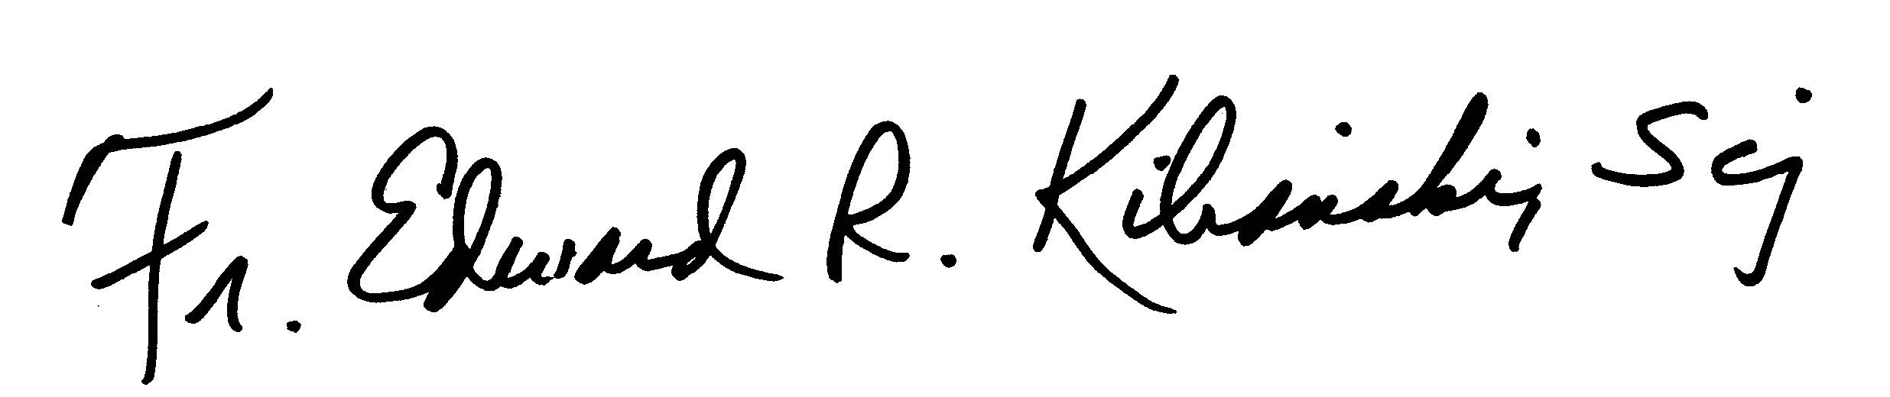

Fr. Edward R. Kilianski, SCJ
Provincial Superior

