As we prepare to commemorate the centenary of his death (August 12, 2025), these monthly biographical sketches will provide an overview of his life and legacy.

Leo Gustave Dehon: His Early Life
Leo Gustave Dehon was born on March 14th, 1843, in the French town of La Capelle. His childhood was spent on the family farm, which specialized in raising racehorses, and he often accompanied his mother as she did good works in their village. Leo’s mother had a strong devotion to the Sacred Heart and was a great spiritual influence on him. Leo’s father showed him the much wider world. At age 12, Leo visited the World Exhibition in Paris. That was the beginning of many travels he would take over his lifetime.
Leo discovered his vocation to priesthood during college but his parents did not approve. His father had many worldly aspirations for him and his mother was worried she would lose close contact with him. Both were wrong, but for the time being, Leo listened to them and moved to Paris where he studied law. After law school, Leo’s father sent him on a ten-month tour around the world. Yet his call persisted, and he entered seminary afterwards. In Rome, he was immersed in a rich spiritual environment, pursued theological studies, benefitted from great mentors, and served as a stenographer at Vatican I. By the time his priestly ordination approached, his parents recognized this was his true calling, and they were overjoyed to be present at his ordination.
Next month, we will resume his story as he begins his priestly ministry!
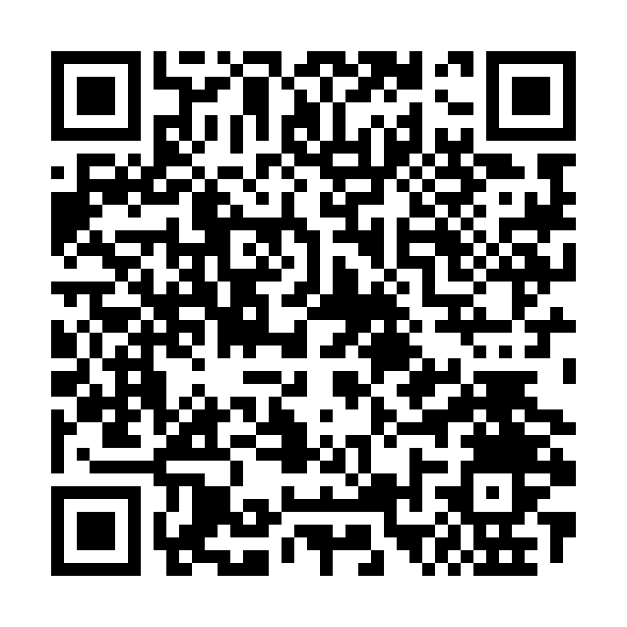
Quote from Fr. Dehon: “Lord, what wilt thou have me do?”
Early in Leo Dehon’s seminary studies, Leo took these words of St Paul (Acts 9:6)
and made them his motto.
Learn more about the Priests of the Sacred Heart (Dehonians/SCJ) at: www.dehoniansusa.org

